COMPETENCY EVIDENCE BRIEF
Testing Across Multiple Devices
Responsive verification at three desktop resolutions with a reproducible physical-device protocol.
Project: Learning Planner Date: 14 August 2026 Status: Manual completion pending

Objective
Demonstrate that Learning Planner remains readable, operable and visually coherent at 1920×1080, 1680×1050 and 1920×1200, then repeat the principal workflow on two genuine computers.

Approach
Repeatability: Playwright set exact viewport dimensions and used the same non-sensitive dataset and core journey at every size. Each capture includes environment metadata.
Physical proof: The manual protocol records manufacturer/model, OS, native resolution, scaling, browser version, inner viewport, tester and date for two computers. These fields cannot be completed by emulation.

Work completed
Responsive system: Used a fixed desktop navigation rail, max-width content, Grid/Flexbox, wrapping controls, viewport-safe dialogs, visible focus, long-text protection and reduced-motion support.
Breakpoint intent: At 1920 px the summary uses one four-card row; at 1680 px it becomes a balanced 2×2 grid; additional 1200 px height exposes more content without stretching controls.
Robustness: A 768×900 check verifies the top-navigation and single-column fallback even though it is outside the formal evidence matrix.
Responsive elements Navigation, summary cards, progress and task panels, goal cards, filters, dates, long titles, validation, focus, dialogs, empty/error states and scrolling were included in the matrix.

Testing performed
Automated: At all three required viewports the persisted CRUD journey, task interaction and page-level overflow assertion passed. The narrow robustness project also passed.
Visual: Full-page captures were inspected for clipping, overlap, font wrapping, spacing, card balance and modal fit. `scrollWidth` equalled `clientWidth` at 1680 after the fix.
Zoom and keyboard: The checklist covers 100%/125% zoom, Tab/Shift+Tab/Enter/Escape, focus visibility, long content and a clean application console.

Outcome
Automated responsive evidence passes for 1920×1080, 1680×1050 and 1920×1200. The two physical sessions are deliberately marked pending; this document is a working competency draft until their metadata and captures replace that status.

Lessons learned
Functional pass is not visual quality: At 1680×1050 the original three-column summary left one orphaned card. Automated overflow checks passed, but visual review exposed weak hierarchy.
Breakpoints should protect composition: Changing to a 2×2 arrangement below 1800 px created balance without smaller text or cramped controls.
Device evidence needs context: Resolution alone is ambiguous when OS scaling and browser chrome change the usable viewport; recording both native and inner dimensions makes results reproducible.
Remaining checkpoint Run DV-01 and DV-02 on real computers, attach the named system/application captures, update the test log and regenerate this package.

SCREENSHOT APPENDIX · EXCLUDED FROM TWO-PAGE NARRATIVE LIMIT
RWD-01 Dashboard at 1920×1080
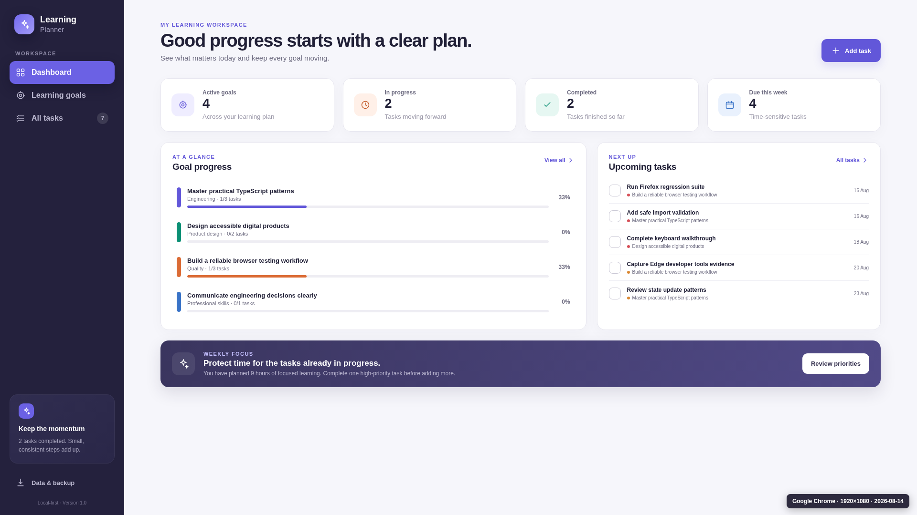
Figure RWD-01. Dashboard at 1920×1080. Generated from non-sensitive sample data.

SCREENSHOT APPENDIX · EXCLUDED FROM TWO-PAGE NARRATIVE LIMIT
RWD-02 Dashboard at 1680×1050 after correction
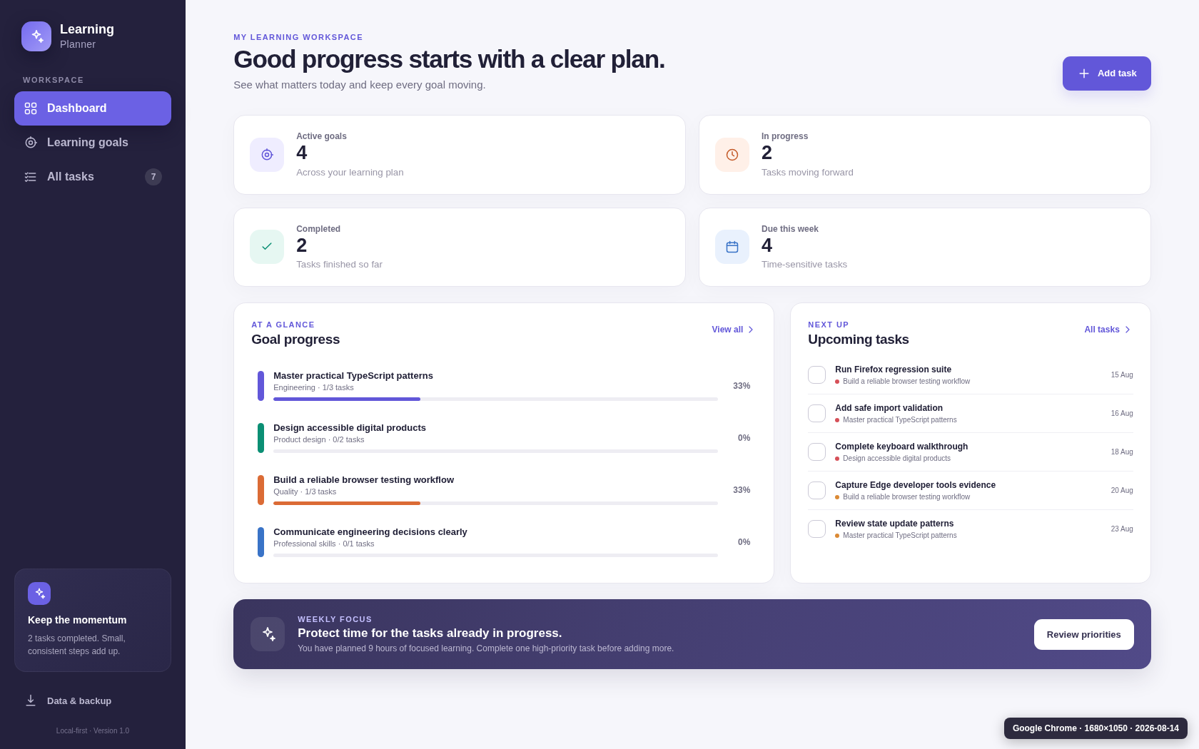
Figure RWD-02. Dashboard at 1680×1050 after correction. Generated from non-sensitive sample data.

SCREENSHOT APPENDIX · EXCLUDED FROM TWO-PAGE NARRATIVE LIMIT
RWD-03 Dashboard at 1920×1200
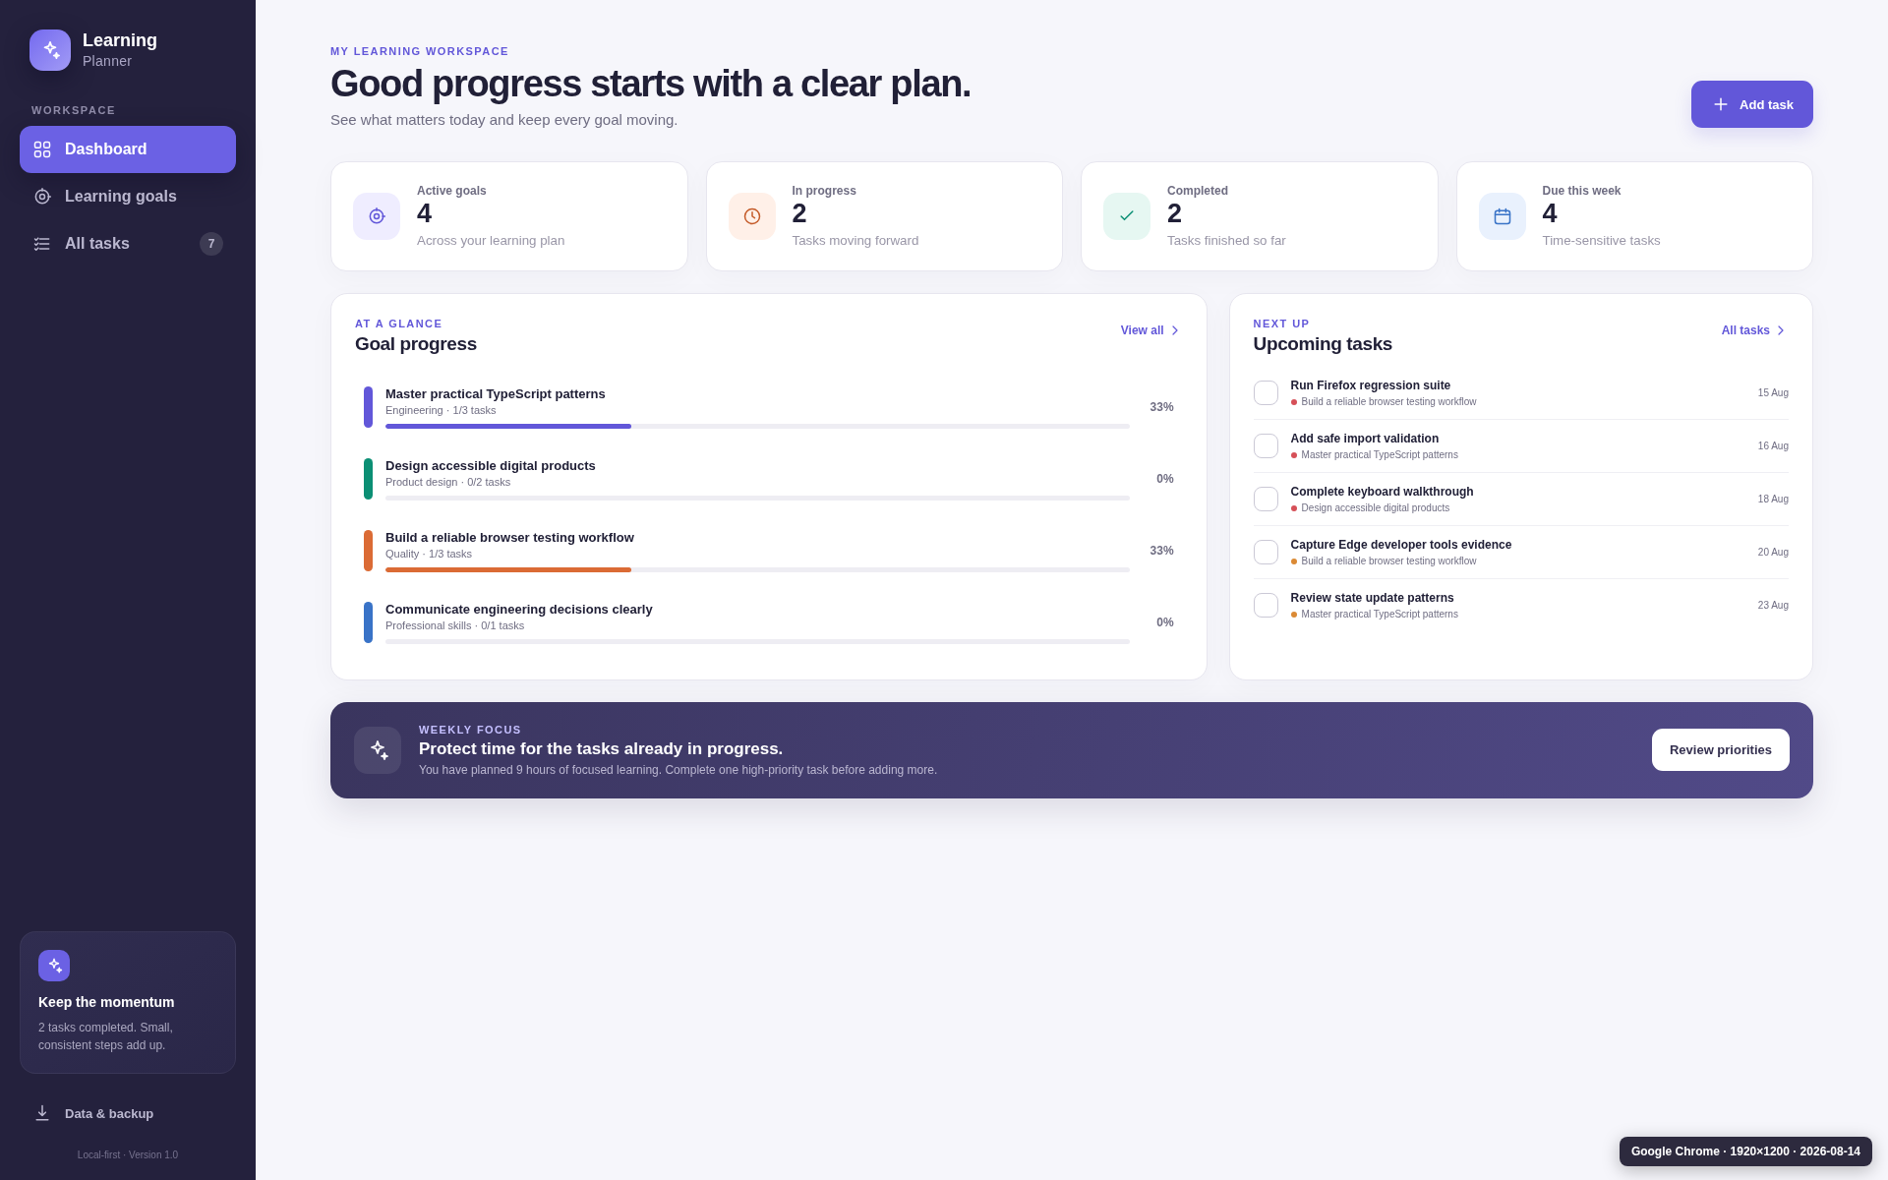
Figure RWD-03. Dashboard at 1920×1200. Generated from non-sensitive sample data.

SCREENSHOT APPENDIX · EXCLUDED FROM TWO-PAGE NARRATIVE LIMIT
RWD-04A Reproduced 1680×1050 card-orphan defect
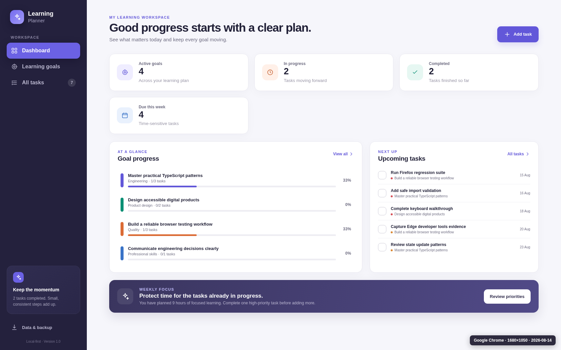
Figure RWD-04A. Reproduced 1680×1050 card-orphan defect. Generated from non-sensitive sample data.

SCREENSHOT APPENDIX · EXCLUDED FROM TWO-PAGE NARRATIVE LIMIT
RWD-04B Corrected balanced 2×2 summary grid
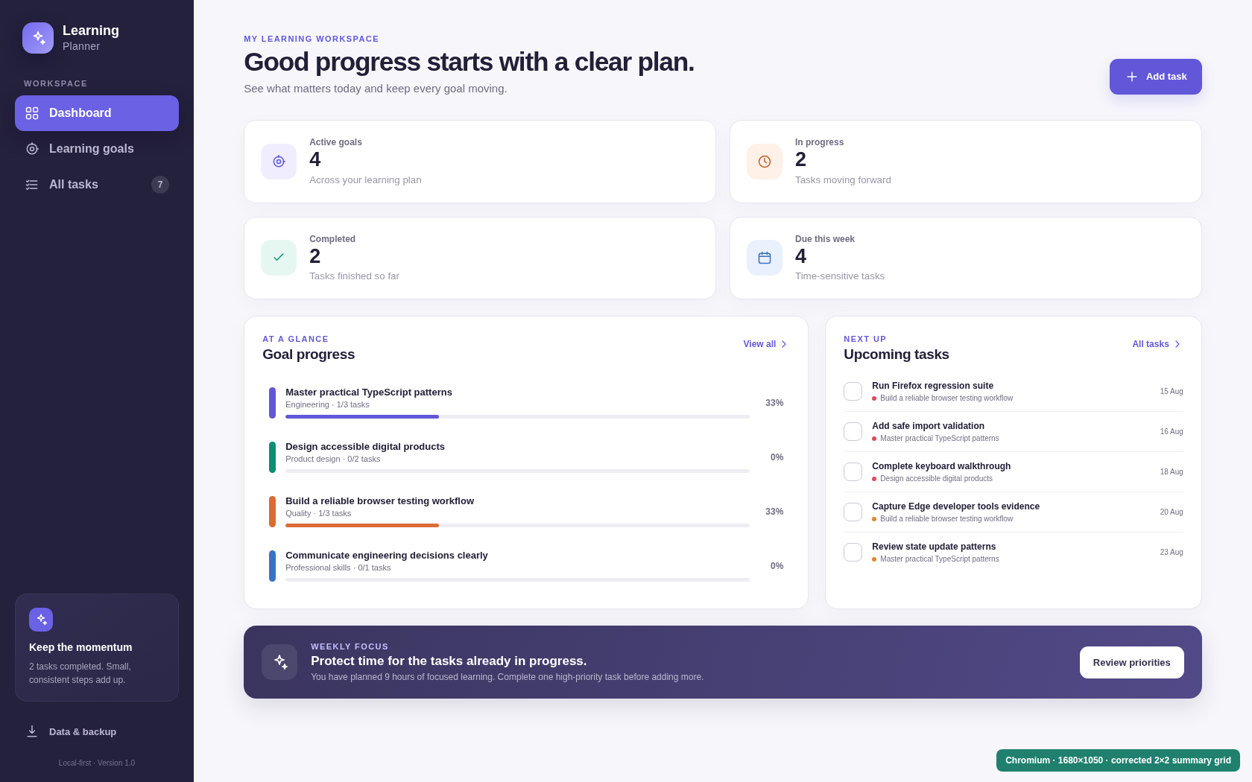
Figure RWD-04B. Corrected balanced 2×2 summary grid. Generated from non-sensitive sample data.

